**Group 3: Flight Price Predictor**

*Kyle Cielencki, Luis Cerrilla, Ahasan Hossain, Artie Edwards*

Our project aims to provide a price predictor on airline flight based on flight data from Bureau of Transportation Statistics. A use-case scenario would be a user trying to retrieve an estimate amount of how much it would cost to travel to a destination based on their origin.

We also provide two dashboards that allow the user to explore the data and understand exactly how price would differ in different areas based on your origin, over time. The second dashboard highlights popular destinations in which travelers frequent often.

The purpose of the machine learning model is to predict the fare for domestic flights in the USA territory given only two inputs, origin airport code and destination airport code. At the end, the Random Forest Regressor provided the best results, which is the model we selected

The data used in this app is from the Bureau of Transportation Statistics (“BTS”) quarterly Airline Origin and Destination Surveys.

The data is visualized with Tableau into two different dashboards and the price predictor was made with D3. All hosted on an HTML webpage. The visualizations are based on a random 5% sample of the last three years of data. This data was combined with an airport city, latitude, and longitude for better visualizations.

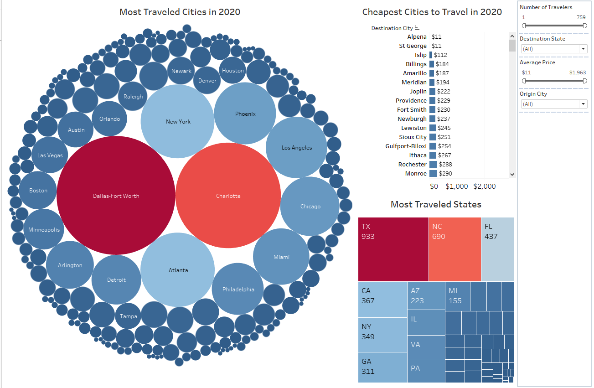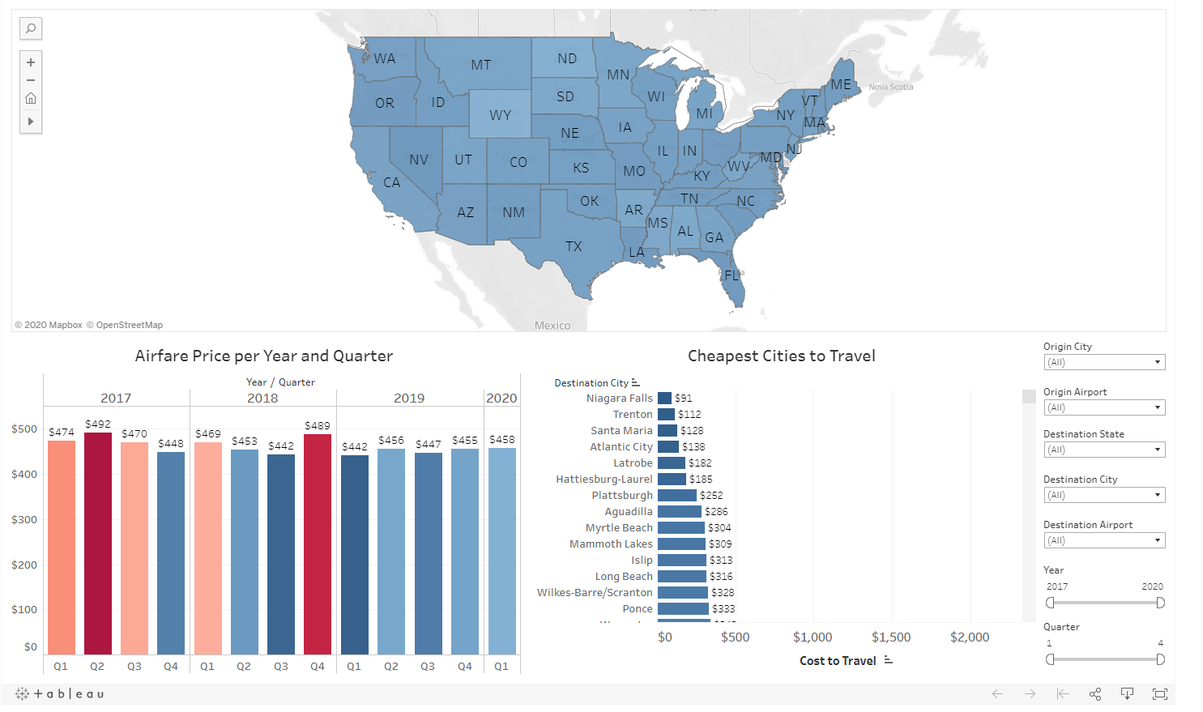

We deployed our site on Heroku and laid out our analysis and prediction model on five pages (Home, Price Predictor, Visualizations, Methodology, About)

